
Faculty of Engineering - University of Ruhuna

Software Requirement Specification
Bodimkarayo.lk
Version 1.0
7/9/24

Version and Approvals
Version History
Version # | Date | Revised By | Reason for change
1.0 | 23-04-2026 | Project Team | Initial SRS document creation

This document has been approved as the official Software Requirements Document for Bodimkarayo.lk – Smart Roommate and Property Finder, and accurately reflects the current understanding of business requirements. Following approval of this document, requirement changes will be governed by the project’s change management process, including impact analysis, appropriate reviews and approvals.

Document Approvals
Approver Name | Project Role |  | Signature/Electronic Approval | Date
Project Team | Initial SRS Creation |  |  | 14/04/2026
Saranga Bandara | Client |  | 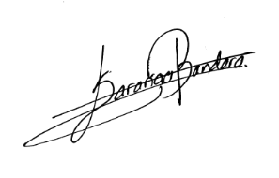 | 14/04/2026

Project Details
Project Name | Bodimkarayo.lk – Smart Roommate & Property Finder
Project Type | New Initiative
Project Start Date | 21/09/2025
Project End Date | 31/05/2026
Project Sponsor | Saranga Bandara
Primary Driver | Improve efficiency and accessibility in property and roommate searching
Secondary Driver | Enhance user experience and trust in rental platforms
Division | Department of Computer Engineering
Project Manager/Dept | EG/2022/4967, EG/2022/4979, EG/2022/5057, EG/2022/5393

Overview
This document defines the high level requirements Bodimkarayo.lk – Smart Roommate & Property Finder. It will be used as the basis for the following activities:
- Creating solution designs
- Developing test plans, test scripts, and test cases
- Determining project completion
- Assessing project success

Document Resources
Name | Business Unit | Role
Saranga Bandara | Client | Project Sponsor and requirement provider
Property Seeker | End Users | Search, view, and interact with property listings and roommate posts
Property Owners | End Users | Create, update, and manage property listings
Roommates | End Users | Create and browse roommate posts for shared accommodation
Admin Users | System | Monitor system activities, manage users, and handle reports
Development Team | Engineering | Design, develop, and implement the system
Project Supervisor | Academic | Evaluate and guide the project development

Glossary of Terms

Term/Acronym | Definition
Bodima | A shared accommodation or boarding place where individuals live together, typically sharing facilities such as rooms, kitchen, and utilities.
Property Seeker | A user who searches for properties or roommates
Property Owner | A user who lists properties for rent
Listing | A property advertisement containing details such as price, location, and facilities
Roommate Post | A post created by users to find shared accommodation partners
Recommendation Engine | An AI-based system that suggests properties or roommates based on user preferences
Chat System | A real-time communication feature that allows users to send and receive messages
Notification System | A feature that sends alerts about new listings, updates, or messages
Admin User | A system user responsible for monitoring and managing platform activities
Admin Log | A record of system activities used for tracking and auditing
CRUD | Create, Read, Update, Delete operations performed on data
JWT | JSON Web Token used for secure authentication
API | Application Programming Interface used for communication between frontend and backend
Database | A structured system used to store and manage application data
Mobile Application | A mobile version of the system accessible through smartphones
Cloud Storage | Online storage used for images and media files

Contents
Version and Approvals 1
Project Details 2
Overview 2
Document Resources 2
Glossary of Terms 3
Introduction 7
1.1 Purpose 7
1.2 Document Conventions 7
1.3 Intended Audience and Reading Suggestions 8
1.4 Product Scope 8
1.5 References 9
Overall Description 10
2.1 Product Perspective 10
2.1.1 System Interfaces 11
2.1.2 Interfaces 12
2.1.3 Hardware Interfaces 12
2.1.4 Software Interfaces 12
2.1.5 Communications Interfaces 13
2.1.6 Memory Constraints 14
2.1.7 Operations 14
2.1.8 Site Adaptation Requirements 14
2.2 Product Functions 15
2.3 User Classes and Characteristics 16
2.4 Operating Environment 16
2.5 Design and Implementation Constraints 17
2.6 Stakeholders 18
2.7 User Documentation 19
2.8 Assumptions and Dependencies 20
2.9 Apportioning of Requirements. 21
2.9.1 Current Release 21
2.9.2 Future Enhancements 21
2.9.3 Long-Term Extensions 21
Functionality Requirements 22
3 22
3.1 User Authentication 22
3.1.1 Description and Priority 22
3.1.2 Stimulus/Response Sequences 22
3.1.3 Functional Requirements / User Stories 22
3.1.4 User Stories 23
3.1.5 Use case diagram 24
3.1.6 Sequence Diagram 27
3.1.7 System Mock-up Screens 28
3.2 Property Management 29
3.2.1 Description and Priority 29
3.2.2 Stimulus/Response Sequences 30
3.2.3 Functional Requirements / User Stories 30
3.2.4 User Stories 30
3.2.5 Use case diagram 31
3.2.6 Sequence Diagram 34
3.2.7 System Mock-up Screens 35
3.3 Roommate Finder 35
3.3.1 Description and Priority 35
3.3.2 Stimulus/Response Sequences 36
3.3.3 Functional Requirements / User Stories 36
3.3.4 User Stories 36
3.3.5 Use case diagram 38
3.3.6 Sequence Diagram 41
3.3.7 System Mock-up Screens 41
3.4 Reviews and Ratings 42
3.4.1 Description and Priority 42
3.4.2 Stimulus/Response Sequences 42
3.4.3 Functional Requirements / User Stories 42
3.4.4 User Stories 43
3.4.5 Use case diagram 44
3.4.6 Sequence Diagram 44
3.4.7 System Mock-up Screens 45
3.5 Logical Database Requirement 46
3.5.1 Introduction 46
3.5.2 Types of Information 46
3.5.3 Frequency of Use 46
3.5.4 Access Capabilities 46
3.5.5 Data Entities 47
3.5.6 Data Relationships 49
3.5.7 Integrity Constraints 49
3.5.8 Data Retention Requirements 49
3.5.9 Data Model Representation 50
Non-functional Requirements 51
4.1 Introduction 51
The non-functional requirements define the quality attributes, constraints, and operational conditions of the Bodimkarayo.lk system. These requirements ensure that the system performs efficiently, remains secure, and provides a reliable and user-friendly experience. The system is designed to support both the web application and the mobile application using a shared backend infrastructure. 51
4.2 Performance Requirements 51
4.3 Safety Requirements 51
4.4 Security Requirements 51
4.5 Software Quality Attributes 52
4.6 Business Rules 54
Other Requirements 55
5.1 Online User Documentation and Help System Requirements 55
5.2 Purchased Components 55
5.3 Interfaces 55
5.3.1 User Interfaces 55
5.3.2 Hardware Interfaces 56
5.3.3 Software Interfaces 56
Frontend - Backend Interface (Web Application) 56
Mobile Application Interface 56
Backend - Database Interface 57
External Service Interfaces 57
Data Exchange and Communication 57
Constraints and Standards 57
5.3.4 Communications Interfaces 58
5.4 Licensing Requirements 58
5.5 Legal, Copyright and Other Notices 58
5.6 Applicable Standards 59
System Architecture 60
6.1 Functional Architecture 61
Functional Hierarchy 61
6.2 Logical Architecture 62
6.3 Component Architecture 62
Component Interactions 63
6.4 Physical Architecture 63
Deployment Structure 64
Physical Mapping of Components 64
Appendix A: Glossary 66
Appendix B: Analysis Models 68
Appendix C: To Be Determined List 69

Introduction

Purpose
This Software Requirements Specification (SRS) document describes the functional and non-functional requirements of the Bodimkarayo.lk – Smart Roommate and Property Finder system, version 1.0.

The system is a web and mobile platform designed to facilitate property searching and roommate matching in Sri Lanka. It provides features such as user authentication, property listing and management, roommate posting, AI-powered recommendations, real-time communication, notifications, and administrative management.

This SRS covers the complete system, including user interfaces, backend services, database management, and integration with external services.

Document Conventions
The following conventions are used throughout this Software Requirements Specification (SRS) document:
- Functional requirements are identified using the format REQ-F-XXX.
- Non-functional requirements are identified using the format REQ-NF-XXX.
- Each requirement is uniquely identified and independently prioritized.

The following keywords are used to indicate requirement levels:
- “Shall” indicates a mandatory requirement that must be implemented.
- “Should” indicates a recommended requirement.
- “May” indicates an optional requirement.

Priority levels are defined as:
- High: Essential for system operation.
- Medium: Important but not critical.
- Low: Optional or enhancement features.

Headings and subheadings are used to organize the document structure clearly. Tables are used where appropriate to present structured information such as definitions and stakeholder details.

Intended Audience and Reading Suggestions
This document is intended for the following stakeholders:

- Developers – to understand system requirements and implement system features
- Testers – to design and execute test cases based on defined requirements
- Project Supervisor – to evaluate project progress and system completeness
- Client/Sponsor – to verify that the system meets business requirements
- End Users – to understand the system capabilities and functionalities
- Maintenance Team – to support and maintain the system after deployment

This Software Requirements Specification (SRS) is organized into several sections. The Introduction section provides an overview of the document and its purpose. The Overall Description section explains the general system characteristics and environment. The System Features section describes detailed functional requirements. The Non-functional Requirements section specifies performance, security, and quality attributes. The System Architecture section presents the system design and structure.

Readers are advised to begin with the Overview and Introduction sections to gain a general understanding of the system, and then proceed to the detailed sections based on their role and interest.

Product Scope
Bodimkarayo.lk – Smart Roommate and Property Finder is a web and mobile platform designed to simplify property searching and roommate matching in Sri Lanka.

The system enables users to create and manage property listings, search for available accommodations, and find suitable roommates based on their preferences. It also provides features such as AI-powered recommendations, real-time communication, notifications, and user reviews to enhance the overall user experience.

The primary objective of the system is to improve efficiency, accessibility, and transparency in the rental and shared accommodation market. By providing a centralized platform, the system reduces the time and effort required for users to find suitable housing options and connect with potential roommates.

This platform supports the broader goal of digital transformation in the housing and rental sector by leveraging modern web technologies and intelligent features to deliver a reliable and user-friendly service.

References
The following documents and resources were used in the preparation of this Software Requirements Specification (SRS):

- Bodimkarayo.lk – Smart Roommate & Property Finder Project Proposal, Project Team, Version 1.0, 2026, Faculty of Engineering, University of Ruhuna.
- React.js Documentation, Meta Platforms Inc., Version 19, 2026, Available at: https://react.dev/
- Spring Boot Documentation, VMware Inc., Version 4.0, 2026, Available at: https://spring.io/projects/spring-boot
- MariaDB Documentation, MariaDB Foundation, Version 11.x, 2026, Available at: https://mariadb.org/documentation/
- Cloudinary Documentation, Cloudinary Ltd., 2026, Available at: https://cloudinary.com/documentation
- OWASP Top Ten Security Risks, OWASP Foundation, 2021, Available at: https://owasp.org/www-project-top-ten/

Overall Description
Bodimkarayo.lk is a platform designed for property listing and roommate finding in Sri Lanka. The system allows users to search for rental properties, create and manage listings, and find compatible roommates based on their preferences.
The application is developed using a client-server architecture with a React-based frontend and a Spring Boot backend connected to a MariaDB database. Cloudinary is used for media storage, and REST APIs are used for communication between the frontend and backend.
The system supports user authentication, profile management, property management, roommate posting, and review features. It also includes capabilities such as personalized recommendations, user interaction features, and access through both web and mobile applications.

Product Perspective
Bodimkarayo.lk is a standalone system developed for property listing and roommate finding. It operates as a complete platform and is not part of an existing system.
The system follows a client-server architecture. The frontend is implemented using React with Tailwind CSS and provides the user interface. The backend is developed using Spring Boot and exposes RESTful APIs for handling application logic, authentication, and data processing. A MariaDB database is used to store system data such as users, properties, roommate posts, and reviews.
The system integrates external services to support its functionality. Cloudinary is used for image storage and management, while Leaflet is used for map-based features. Elasticsearch is used to improve search capabilities. A recommendation component is included to support personalized suggestions.
The platform supports both web and mobile access, with the mobile application developed using Flutter. All components work together to provide a unified environment for managing property listings and roommate interactions.

System Interfaces
- MariaDB Database System
MariaDB is used as the primary relational database of the system. It stores structured data including user accounts, authentication-related data, property listings, roommate posts, reviews, and administrative records. The backend communicates with the database through Spring Data JPA for data persistence and retrieval.

- Cloudinary Media Service
Cloudinary is used for storing, managing, and delivering uploaded media files such as property images and user profile pictures. The system sends image files to Cloudinary during upload operations and retrieves stored image URLs for display in the frontend.

- Leaflet Map Integration
Leaflet is used to support map-related functionality in the system. It enables location-based visualization of properties and helps users understand the geographical context of listings. Property location references and map-related data are presented through this interface.

- Elasticsearch Search Service
Elasticsearch is used to support advanced search functionality. It improves the efficiency of searching, filtering, and retrieving property-related information based on user queries and listing attributes.

- Recommendation Engine
The system includes an interface for a recommendation component that provides personalized property or roommate suggestions based on user preferences and relevant listing information. This interface supports recommendation-related processing between the application and the recommendation logic.

- Mobile Application Interface
The system also supports access through a mobile application developed using Flutter. The mobile application uses the same backend services and provides access to core platform features in a mobile-friendly environment.

- AWS Hosting and Deployment Environment
AWS is used as the hosting and deployment platform for system components. It provides the infrastructure required to run the application and support its availability, scalability, and online access.

Interfaces
The system provides a graphical user interface (GUI) for user interaction. Users access the platform through a web application using standard web browsers and through a mobile application.
The interface is designed to be responsive and user-friendly, allowing users to navigate the system efficiently across different devices such as desktops, tablets, and smartphones. Users interact with the system through pages, forms, buttons, and interactive components.
The system supports structured interactions for tasks such as user registration, login, profile management, property listing, roommate posting, and review submission. Input validation is applied to ensure correct data entry, and clear feedback messages are displayed for user actions. The interface is designed to provide consistent navigation, clear layouts, and easy access to system functions for different user types.

Hardware Interfaces
The system has no hardware interface requirements. It does not interact with or control any specific hardware devices. The application is accessed through standard user devices such as desktops, laptops, tablets, and smartphones using web browsers or mobile application.

Software Interfaces
Name | Mnemonic | Version | Source
MariaDB | DB | 12.x | MariaDB Foundation
Cloudinary | CMS | Latest | Cloudinary
Elasticsearch | ES | 8.x | Elastic
Leaflet | MAP | 1.x | LeafletJS
Spring Boot | API | 4.x | Spring
React | UI | 19.x | Meta
Flutter | Mobile | 3.x | Google

Interface description
- MariaDB Database System
MariaDB is used to store and manage application data such as users, properties, roommate posts, reviews, and logs. The backend interacts with the database using SQL queries through Spring Data JPA. Data is exchanged in structured table format.

- Cloudinary Media Service
Cloudinary is used to store and retrieve images uploaded by users. The system sends image files using multipart/form-data requests and receives secure URLs for displaying images.
- Elasticsearch Search Service
Elasticsearch is used to enhance search functionality. It processes search queries and returns filtered results based on listing attributes such as location and price.

- Leaflet Map Library
Leaflet is used to display map-based data in the frontend. It visualizes property locations using coordinates or map URLs.

- Spring Boot Backend APIs
The backend exposes RESTful APIs for handling system operations. Requests and responses are exchanged in JSON format over HTTP/HTTPS.

- React Frontend Application
React is used to build the user interface and communicate with backend APIs using HTTP requests.

- Flutter Mobile Application
The mobile application interacts with the same backend APIs and provides access to system features through a mobile interface.

Communications Interfaces
- HTTP/HTTPS Protocol
Communication between the frontend, mobile application, and backend services is performed using HTTP and HTTPS protocols. HTTPS is used to ensure secure data transmission.

- RESTful API Communication
The backend exposes RESTful APIs that are used by the frontend and mobile applications. These APIs handle operations such as authentication, data retrieval, data submission, and updates.

- Data Format (JSON)
All request and response data between client applications and backend services are exchanged in JSON format.

- Multipart Data Transfer
File upload operations, such as image uploads, use multipart/form-data for transferring binary data along with form fields.

Memory Constraints
There are no specific memory constraints defined for the system. The application is designed to run on standard web and server environments with sufficient memory to support normal operation of the frontend, backend, and database components.

Operations
The system operates as an interactive application where users perform actions such as registration, login, searching properties, managing listings, and posting roommate requests.
The system supports different modes of operation, including user-level access for tenants and property owners, and administrative access for system monitoring and management.
User interactions are processed in real time, while background operations such as data storage, image handling, and activity logging are performed without direct user involvement.
The system processes data through database operations for storing and retrieving user, property, and roommate information. Administrative functions include monitoring system activity and managing platform data. The system also supports maintenance operations such as database backup and recovery to ensure data integrity and system reliability.

Site Adaptation Requirements
The system is deployed in a cloud environment using AWS EC2 and Docker containers. The deployment environment must support required runtime dependencies and container execution.
Before system activation, a MariaDB database instance must be created and configured. Required environment variables, including database connection details, JWT configuration, and Cloudinary credentials, must be properly set.
Docker containers for the frontend, backend, and database services must be configured and executed with proper network settings to enable communication between components.
The deployment environment must also configure necessary access settings such as ports, domain mapping, and security rules to allow controlled public access to the application.
The system requires initialization steps including database setup, environment configuration, and service startup before it becomes fully operational.
No special hardware setup is required, as the system operates entirely in a cloud-based environment.

Product Functions
Bodimkarayo provides the following major system functions:
- User Account Management
User registration, login, profile management, profile image upload, and role-based access control.
- Property Listing Management
Creation, update, deletion, and browsing of property listings with detailed information and multiple images.
- Roommate Finder
Creation and management of roommate posts, browsing available posts, and viewing detailed roommate information.
- Property and Roommate Search
Searching and filtering of properties and roommate posts based on location and other attributes.
- Review and Rating System
Submission, viewing, and deletion of reviews for properties and users.
- Recommendation Functionality
Generation of personalized property and roommate suggestions based on user preferences.
- Administrative Functions
Monitoring system activity and managing administrative operations.
- Media Management
Uploading, storing, and retrieving images using cloud-based services.
- Security and Validation
Authentication, authorization, and validation of user input across system operations.

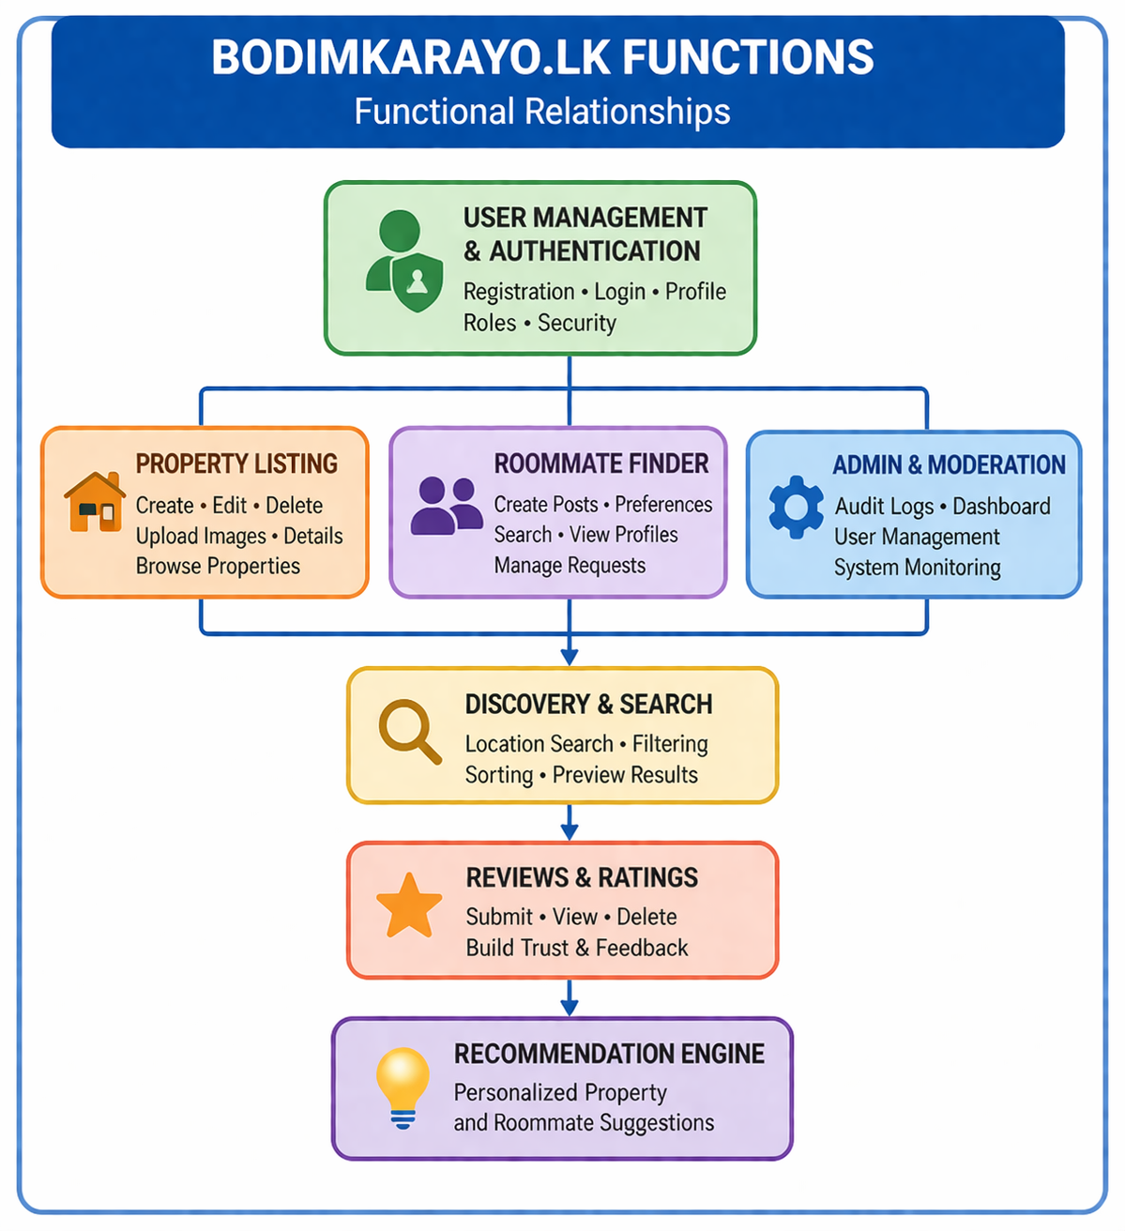

User Classes and Characteristics
The Bodimkarayo system supports multiple user classes with different roles, access levels, and usage patterns.
- Property Seekers (Primary Users)
Individuals searching for rental properties or shared accommodation.
They frequently use the system to browse listings, apply filters, view details, and submit reviews.
These users typically have low to moderate technical expertise and require a simple and responsive interface.
- Property Owners (Primary Users)
Users who create and manage property listings.
They use the system to add, update, and delete listings, upload images, and manage property information.
They require reliable access and efficient tools for managing their listings.
- Roommate Seekers (Primary Users)
Users looking for shared accommodation and compatible roommates.
They create and manage roommate posts, browse profiles, and specify preferences such as location, budget, and lifestyle.
These users often prioritize compatibility and privacy.
- Administrators (Secondary but Critical Users)
Users responsible for monitoring and managing the system.
They access system logs, monitor activity, and handle administrative tasks.
They require higher technical expertise and privileged access.
- Guest or Anonymous Users (Supporting Users)
Unregistered users who browse limited content.
Their goal is to explore the platform before registering.
They have minimal access and limited interaction capabilities.

Operating Environment
The Bodimkarayo system operates as a web-based client-server application. The frontend is implemented using React and runs in modern web browsers, while the backend is developed using Spring Boot and runs on a Java 17 runtime environment. The system uses MariaDB as the relational database. The application is deployed in a cloud environment using AWS EC2 with a Linux operating system. Docker is used as the container runtime to package and run the frontend, backend, and database components. A reverse proxy such as Nginx is used to manage routing and HTTPS communication.
End users access the system through standard web browsers such as Chrome, Edge, Firefox, and Safari on desktop or mobile devices. The system requires internet connectivity and a browser with JavaScript enabled. The system is designed to operate across different environments including development, testing, and production, with environment-specific configurations for database connections, API endpoints, and external services.

Design and Implementation Constraints
The Bodimkarayo system shall be developed and deployed under the following constraints, which limit design choices, technology options, and implementation flexibility.
- Regulatory and Policy Constraints
The system shall comply with applicable data privacy and security practices for handling user information such as email, profile data, images, and authentication credentials. The project shall also follow university guidelines, documentation standards, and ethical handling of user-generated content.

- Hardware and Infrastructure Constraints
The system shall operate within the resource limits of a cloud-based environment, specifically AWS EC2 or an equivalent platform. Compute, memory, and storage availability will influence system performance and scalability.

- Interface Constraints
The system design must remain compatible with external services such as MariaDB for data storage and Cloudinary for media management. Integration must follow the operational limits and API structures of these services.

- Parallel Operation Constraints
The system shall support concurrent execution of frontend, backend, and database services within a Docker-based environment. Multiple users must be able to perform operations such as listing creation, image uploads, and search without data inconsistency.

- Audit Function Constraints
The system shall maintain audit logs of important user and administrative actions to support monitoring, troubleshooting, and accountability.

- Control Function Constraints
Role-based access control shall be enforced using defined roles such as USER, OWNER, and ADMIN. Access to sensitive operations shall be restricted based on these roles.

- Technology Constraints
The system shall be implemented using the defined technology stack, including React for frontend development, Spring Boot with Java 17 for backend services, MariaDB for persistence, Docker for containerization, and AWS EC2 for deployment.

- Communication Protocol Constraints
System communication shall use RESTful APIs over HTTP/HTTPS with JSON data formats and multipart/form-data for file uploads. Low-level communication protocols are not applicable.

- Reliability Constraints
The system shall provide stable operation with proper error handling, service coordination, and data consistency. Database availability and correct startup sequence of system components must be ensured.

- Application Criticality Constraints
The system is not safety-critical but is operationally important. Failures may result in data inconsistency, service disruption, and reduced user trust, therefore correctness and availability are required.

- Security Constraints
The system shall enforce secure authentication and authorization mechanisms using JWT, password hashing, and protected API endpoints. Secure communication over HTTPS and proper management of sensitive configuration data are required.

- Design and Coding Constraints
The system shall follow a structured architecture with clear separation of concerns between frontend, backend, and data layers. Consistent coding standards and modular design shall be maintained to ensure maintainability and future scalability.

Stakeholders
The following comprises the internal and external stakeholders whose requirements are represented by this document:

 | Stakeholders
1. | Project Client (External)  Defines system goals, validates requirements, and approves deliverables.
2. | End Users (External)  Includes property seekers, property owners, and roommate seekers who use the system for searching, posting, and managing listings.
3. | Platform Administrators (Internal)  Responsible for monitoring system activity, managing logs, and enforcing platform policies.
4. | Development Team (Internal)  Responsible for system development, testing, evaluation, and ensuring project quality.

User Documentation
The following user documentation components will be provided with the Bodimkarayo system:
- End-User Guide
Covers account creation, login, property search, roommate posts, profile management, and review submission.
Delivered as PDF and web-based documentation.

- Administrator Guide
Covers system monitoring, log management, and moderation tasks.
Delivered as a technical guide document.

- In-Application Help
Includes form instructions, validation messages, and error notifications integrated within the user interface.

- Technical Documentation
Includes deployment, configuration, and API usage details for developers and system maintainers.
Delivered as Markdown and PDF documents.

Assumptions and Dependencies

# | Assumptions
1 | Users have stable internet access and modern web browsers.
2 | Users provide accurate profile, listing, and roommate information.
3 | AWS EC2 environment will be available for deployment.
4 | MariaDB and Cloudinary services will be available and properly configured.
5 | The agreed technology stack will remain unchanged during the project.
6 | Project timeline and team resources will remain stable.
# | Dependencies
1 | AWS EC2 environment and network configuration.
2 | Docker runtime environment.
3 | MariaDB database service.
4 | Cloudinary service.
5 | Domain and SSL/TLS configuration.
6 | Browser compatibility.
7 | Third-party frameworks and libraries.
# | Constraints
1 | Must use React, Spring Boot, and MariaDB.
2 | Deployment must support Docker on AWS EC2.
3 | Communication must use REST over HTTP/HTTPS with JSON and multipart data.
4 | Security must include authentication, authorization, and password hashing.
5 | Development must fit within academic timeline and team size.
6 | Infrastructure capacity may limit performance.
7 | Advanced features may be moved to later phases if time is insufficient.

Apportioning of Requirements.
Due to project timeline and resource constraints, the system requirements are divided into current and future releases.

Current Release
The current release includes the core functionality of the system across both web and mobile platforms:
- User registration and login with authentication
- User profile management and image upload
- Property listing creation, update, deletion, and browsing
- Property search and filtering
- Roommate post creation and browsing
- Review and rating functionality
- Role-based access control
- Mobile application support
- Deployment using Docker on AWS EC2

Future Enhancements
The following features are planned for future versions:
- Advanced recommendation functionality
- User messaging and communication features
- Notification system
- Full administrative dashboard
- Enhanced search and filtering capabilities

Long-Term Extensions
- Advanced analytics and reporting
- Scalability and performance improvements

Functionality Requirements
<This template illustrates organizing the functional requirements for the product by system features, the major services provided by the product. You may prefer to organize this section by use case, mode of operation, user class, object class, functional hierarchy, or combinations of these, whatever makes the most logical sense for your product.>

User Authentication

Description and Priority
The User Authentication feature enables users to securely register, log in, and access the system using role-based authorization. It ensures that only authenticated users can perform protected actions such as creating listings and posting roommate requests.

Priority: High

- Benefit: 9
- Penalty: 9
- Cost: 6
- Risk: 5

Stimulus/Response Sequences
Stimulus | System Response
User enters registration details | System validates input and creates user account
User submits login credentials | System verifies credentials
Valid credentials provided | System generates JWT token and grants access
Invalid credentials provided | System returns error message
User accesses protected endpoint | System validates token and allows/denies access
Token expired or invalid | System denies access and requests login

Functional Requirements / User Stories
- REQ-F-001: The system shall allow users to register using email and password.
- REQ-F-002: The system shall validate user input fields (email format, password strength).
- REQ-F-003: The system shall prevent duplicate account creation using the same email.
- REQ-F-004: The system shall allow users to log in using valid credentials.
- REQ-F-005: The system shall generate a JWT token upon successful login.
- REQ-F-006: The system shall securely store passwords using BCrypt hashing.
- REQ-F-007: The system shall enforce role-based access control (e.g., USER, ADMIN).
- REQ-F-008: The system shall restrict access to protected resources for unauthenticated users.
- REQ-F-009: The system shall return appropriate error messages for invalid login attempts.
- REQ-F-010: The system shall invalidate access when token is expired or malformed.
- REQ-F-011: The system shall persist authentication state on the client side.

User Stories

User story ID: US01
User Role: Guest
Description: As a guest, I want to register an account so that I can access the system features.
Acceptance Criteria:
- User can enter valid email and password
- System validates inputs
- Account is successfully created

Supporting Information/Reference: Registration form
Output: User account created
Dependencies: Database connection
Integration: Backend API

User story ID: US02
User Role: Registered User
Description: As a user, I want to log in securely so that I can access my account.
Acceptance Criteria:
- User enters correct credentials
- System returns JWT token
- User is redirected to dashboard

Supporting Information/Reference: Login form
Output: Authenticated session
Dependencies: Authentication API
Integration: Frontend + Backend

User story ID: US03
User Role: System User
Description: As a user, I want error messages for invalid login so that I understand what went wrong.
Acceptance Criteria:
- Incorrect password → error shown
- Invalid email → error shown

Supporting Information/Reference: Login form
Output: Error message displayed
Dependencies: Authentication API
Integration: Frontend + Backend

Use case diagram
Use Case ID: | UC-01
Use Case Name: | User Login
Created By: | Bodhinayake B.D.S.S. | Last Updated By:
Date Created: | 11/04/2026 | Date Last Updated:

Actors: | Registered User
Description: | This use case allows a registered user to log into the system using valid credentials.
Preconditions: | - User must have a registered account  - System must be running
Postconditions: | - User is authenticated  - JWT token is generated
Normal Course: | - User enters email and password  - System validates credentials  - System generates JWT token  - User is logged in
Alternative Courses: | - Invalid credentials entered  - System displays error message
Exceptions: | - Server unavailable  - System returns failure response
Includes: | - Token validation
Priority: | High
Frequency of Use: | Very frequent (every login session)
Business Rules | - Email must be unique  - Password must meet security criteria
Special Requirements: | - Response time < 3 seconds  - Secure password storage
Assumptions: | Users have internet access
Notes and Issues: | Password reset functionality is TBD
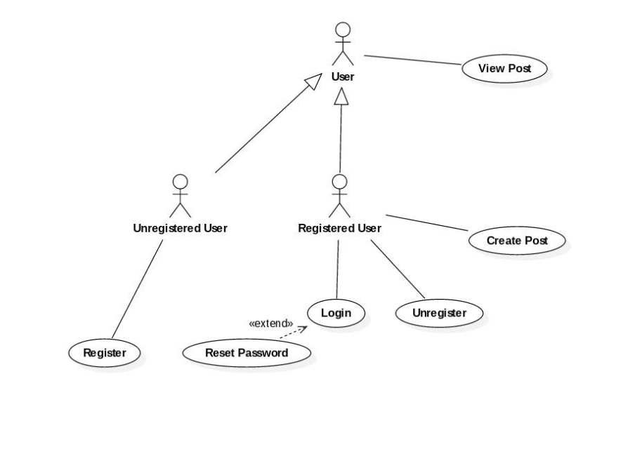
Use Case Graphic

Sequence Diagram
Draw the sequence diagram for the relevant system feature or use case

Sample
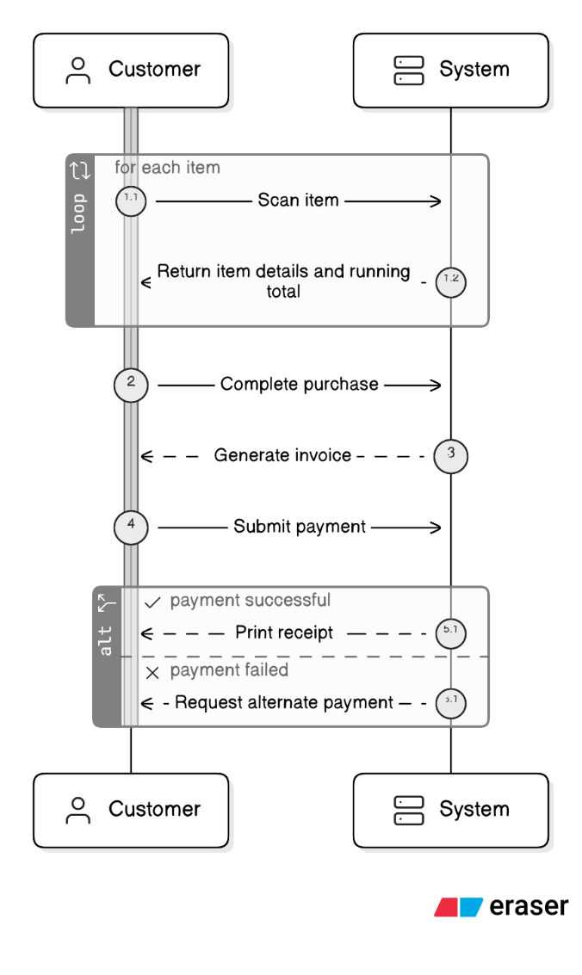

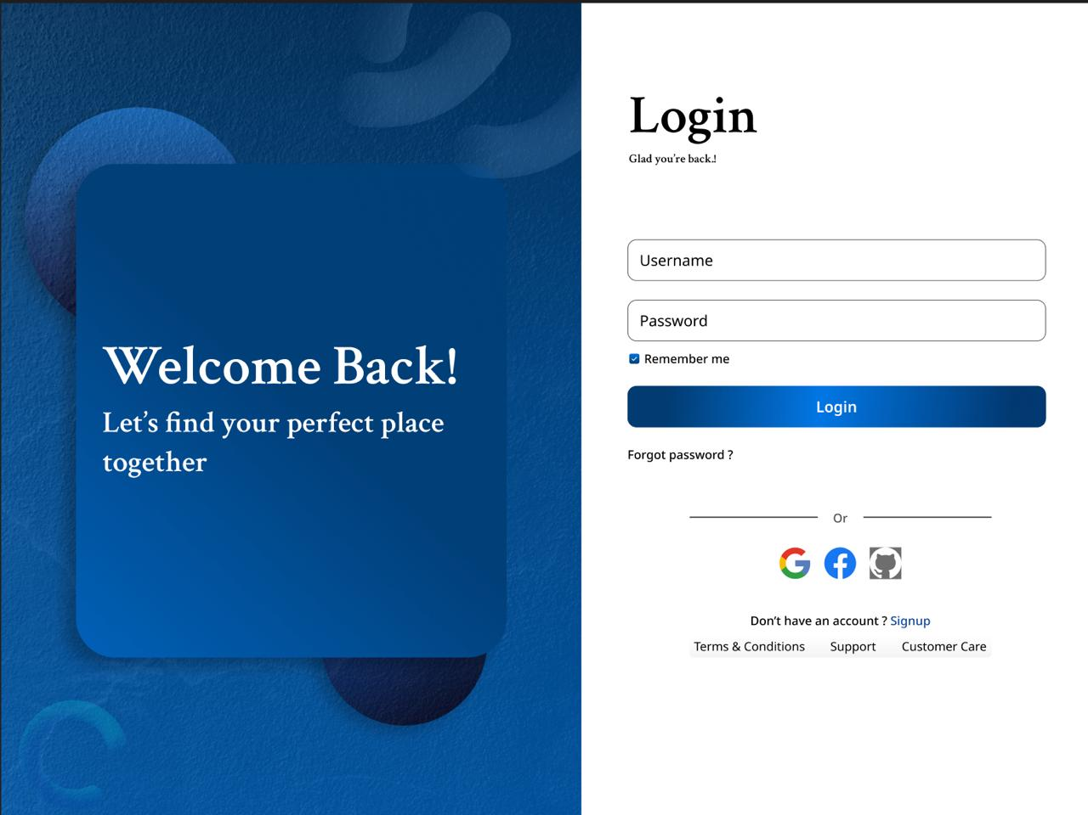
System Mock-up Screens

Property Management

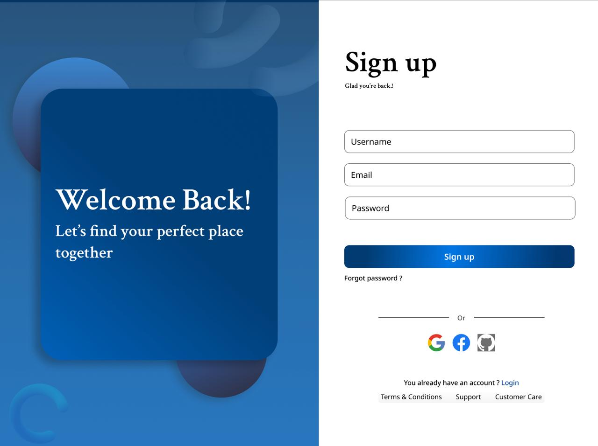
Description and Priority
The Property Management feature allows authenticated users (property owners) to create, update, delete, and view property listings with detailed information such as rent, location, facilities, and images. It enables tenants to search and explore available properties efficiently.

Priority: High

- Benefit: 9
- Penalty: 8
- Cost: 7
- Risk: 6

Stimulus/Response Sequences
Stimulus | System Response
User submits property details | System validates and stores data
User uploads images | System uploads images to Cloudinary
User requests property list | System returns list of properties
User updates property | System saves updated details
User deletes property | System removes listing
User enters invalid data | System returns validation errors

Functional Requirements / User Stories
- REQ-F-100: The system shall allow authenticated users to create property listings.
- REQ-F-101: The system shall validate all required fields before submission.
- REQ-F-102: The system shall allow users to upload multiple images per property.
- REQ-F-103: The system shall store property details including title, description, rent, and location.
- REQ-F-104: The system shall allow users to edit their property listings.
- REQ-F-105: The system shall allow users to delete their property listings.
- REQ-F-106: The system shall allow users to search properties by location.
- REQ-F-107: The system shall display detailed property information including images.
- REQ-F-108: The system shall prevent unauthorized users from modifying listings.
- REQ-F-109: The system shall return appropriate error messages for invalid input data.

User Stories

User story ID: US-10
User Role: Property Owner
Description: As an owner, I want to add property listings so that tenants can find my property.
Acceptance Criteria:
- Owner can enter all required fields
- Images can be uploaded
- Listing is successfully saved

Supporting Information/Reference: Property input form (frontend UI), Cloudinary image upload service
Output: Property listing created
Dependencies: User must be authenticated , Database connection (MariaDB), Cloudinary service availability
Integration: Frontend (React form submission), Backend (Spring Boot API), Cloudinary (image storage)

User story ID: US11
User Role: Tenant
Description: As a tenant, I want to search properties so that I can find suitable accommodation .
Acceptance Criteria:
- User enters location or filters
- System returns matching properties
- Results displayed correctly

Supporting Information/Reference: Search bar UI
Output: List of matching properties displayed
Dependencies: Property data must exist in database, Backend API must be running
Integration: Frontend search component, Backend search API, Database query system

User story ID: US12
User Role: Property Owner
Description: As an owner, I want to edit my listings so that I can update property details.
Acceptance Criteria:
- Owner can modify property details
- Changes are saved successfully
- Updated details are visible

Supporting Information/Reference: Edit property form
Output: Updated property listing
Dependencies: User must be owner of the property, Authentication system
Integration: Frontend edit form

Use case diagram
Use Case ID: | UC-10
Use Case Name: | Create Property Listing
Created By: | Bodhinayake B.D.S.S. | Last Updated By:
Date Created: | 11/04/2026 | Date Last Updated:

Actors: | Property Owner
Description: | This use case allows a property owner to create a new property listing by entering property details and uploading images so that tenants can view and search for available properties.
Preconditions: | - User must be authenticated  - User must have property owner role  - System must be running
Postconditions: | - Property listing is stored in the database  - Images are uploaded successfully  - Listing is available for viewing by users
Normal Course: | - User navigates to add property page  - User enters property details (title, rent, location, etc.)  - User uploads images  - System validates input data  - System uploads images to Cloudinary  - System stores property details in database  - System confirms successful creation
Alternative Courses: | - User submits incomplete or invalid data.  - System displays validation errors
Exceptions: | - Image upload fails  - System displays error message
Includes: | - Image Upload  - Data Validation
Priority: | High
Frequency of Use: | Frequent
Business Rules | - Only authenticated users can create property listings  - Property must include required fields (title, rent, location)  - Users can only modify their own listings
Special Requirements: | - Image upload size limit must be enforced  - Response time should be less than 3 seconds
Assumptions: | - Users have internet access  - Cloudinary service is available
Notes and Issues: | Advanced filtering features are TBD
Use Case Graphic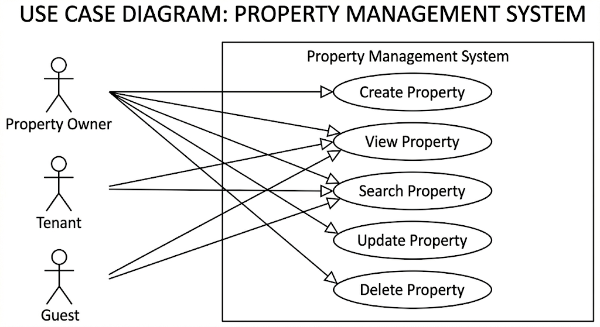

Sequence Diagram
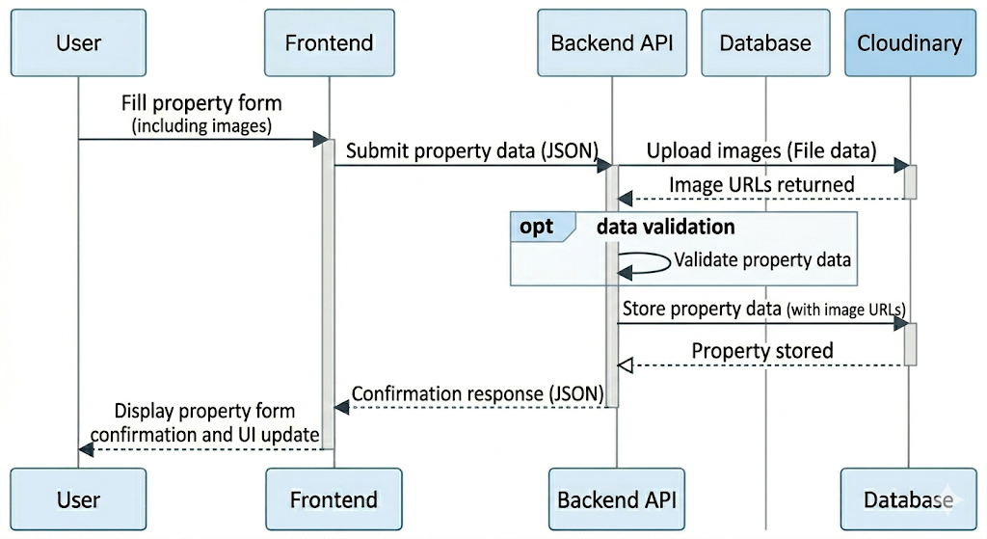

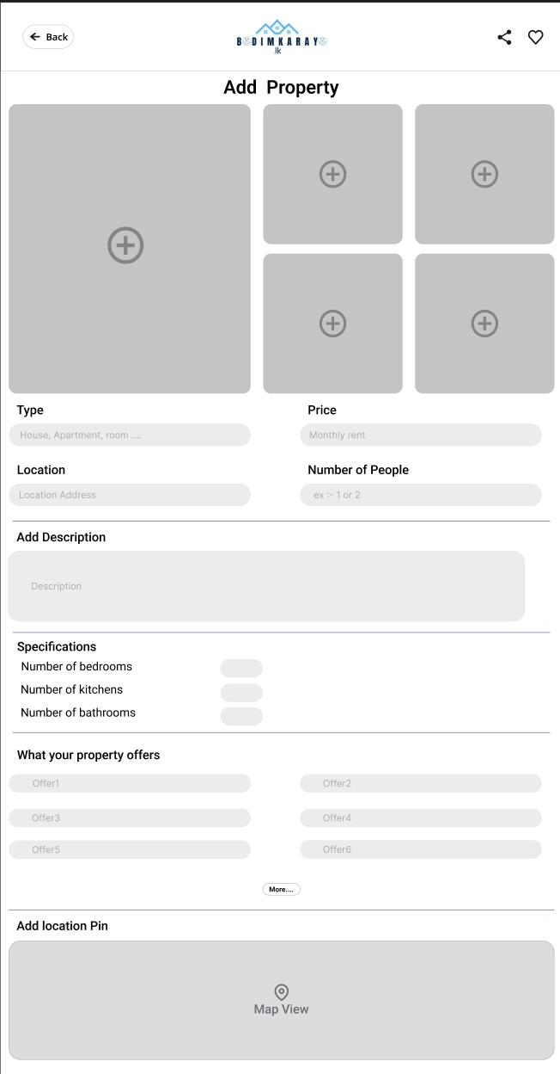
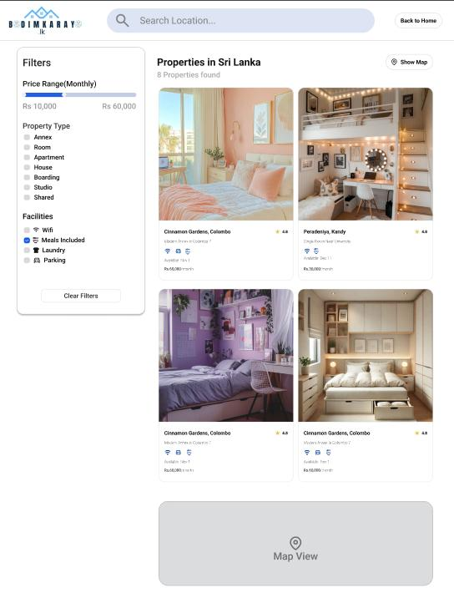
System Mock-up Screens

Roommate Finder

Description and Priority
The Roommate Finder feature allows authenticated users (tenants/students) to find compatible roommates based on preferences such as budget, location, lifestyle, and gender preference. Users can create roommate profiles, browse other profiles, and send/receive connection requests to form potential roommate matches.
This feature improves shared accommodation efficiency and reduces rental costs by enabling users to find suitable roommates before renting or moving in.

Priority: High

- Benefit: 9
- Penalty: 8
- Cost: 6
- Risk: 6

Stimulus/Response Sequences
Stimulus | System Response
User creates roommate profile | System validates and stores profile
User updates preferences | System updates profile data
User searches roommates | System returns matching profiles
User sends connection request | System stores request and notifies receiver
User accepts/rejects request | System updates connection status
User enters invalid data | System returns validation errors

Functional Requirements / User Stories
- REQ-F-200: The system shall allow users to create a roommate profile.
- REQ-F-201: The system shall allow users to set preferences (budget, location, lifestyle).
- REQ-F-202: The system shall allow users to search for potential roommates.
- REQ-F-203: The system shall allow users to send connection requests.
- REQ-F-204: The system shall allow users to accept or reject requests.
- REQ-F-205: The system shall display roommate profile details.
- REQ-F-206: The system shall validate all profile input data.
- REQ-F-207: The system shall prevent unauthorized access to private profile data.
- REQ-F-208: The system shall notify users of new connection requests.
- REQ-F-209: The system shall allow users to update or delete their roommate profile.

User Stories

User story ID: US-20
User Role: Tenant
Description: As a user, I want to create a roommate profile so that I can find compatible roommates.
Acceptance Criteria:
- User can enter preferences (budget, location, lifestyle)
- Profile is successfully saved
- Profile is visible in search results

Supporting Information/Reference: Roommate finder form
Output: Roommate profile created
Dependencies: Authentication system, database
Integration: Frontend profile form, backend API

User story ID: US21
User Role: Tenant
Description: As a user, I want to search for roommates so that I can find suitable matches.
Acceptance Criteria:
- User can apply filters (budget, location, etc.)
- System returns matching profiles
- Results are displayed correctly

Supporting Information/Reference: Search bar UI
Output: List of roommate profiles
Dependencies: Existing roommate profiles in database
Integration: Search UI + backend filtering API

User story ID: US22
User Role: Tenant
Description: As a user, I want to send connection requests so that I can contact potential roommates.
Acceptance Criteria:
- User can send request
- Receiver gets notification
- Request status is stored

Supporting Information/Reference: Edit property form
Output: Connection request created
Dependencies: Notification system
Integration: Messaging/notification module

Use case diagram
Use Case ID: | UC-20
Use Case Name: | Create Roommate Profile
Created By: | Bodhinayake B.D.S.S. | Last Updated By:
Date Created: | 11/04/2026 | Date Last Updated:

Actors: | Tenant
Description: | Allows user to create a roommate profile with preferences to find suitable roommates.
Preconditions: | - User must be authenticated  - User must have tenant/student role
Postconditions: | - Profile stored in database  - Profile available for matching
Normal Course: | - User opens roommate profile page  - User enters preferences  - System validates input  - System stores profile  - System confirms creation
Alternative Courses: | Invalid data → system shows validation errors
Exceptions: | Database failure → system shows error message
Includes: | - Data Validation  - Profile Storage
Priority: | High
Frequency of Use: | Frequent
Business Rules | - Only authenticated users can create profiles
Special Requirements: | - Search results should load in < 3 seconds
Assumptions: | - Users have internet access
Notes and Issues: | Advanced filtering features are TBD

Use Case ID: | UC-21
Use Case Name: | Search Roommates
Created By: | Bodhinayake B.D.S.S. | Last Updated By:
Date Created: | 11/04/2026 | Date Last Updated:

Actors: | Tenant
Description: | Allows users to search and filter roommate profiles.
Preconditions: | - User must be authenticated  - Roommate profiles must exist  - System must be running
Postconditions: | - Matching profiles displayed
Normal Course: | - User opens search page  - User sets filters  - System queries database  - System returns results
Alternative Courses: | No match found → system shows empty state
Exceptions: | Database error  → System shows error message
Includes: | - Search Filtering  - Data Retrieval
Priority: | High
Frequency of Use: | Frequent
Business Rules | - Users can only view public profiles  - Filters must be applied correctly
Special Requirements: | - Search results should load within 3 seconds
Assumptions: | - Profiles exist in database  - Backend API is functional
Notes and Issues: | Advanced filtering features are TBD

Sequence Diagram
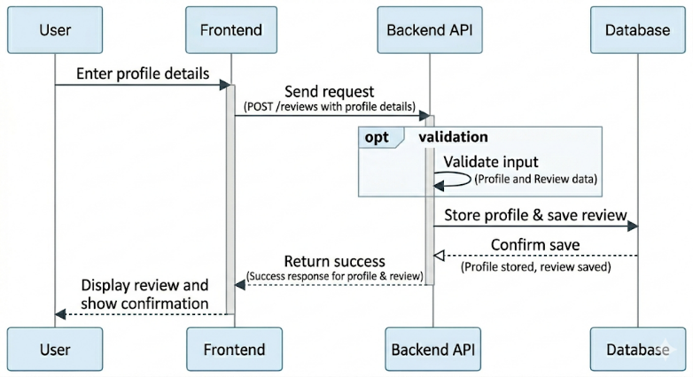

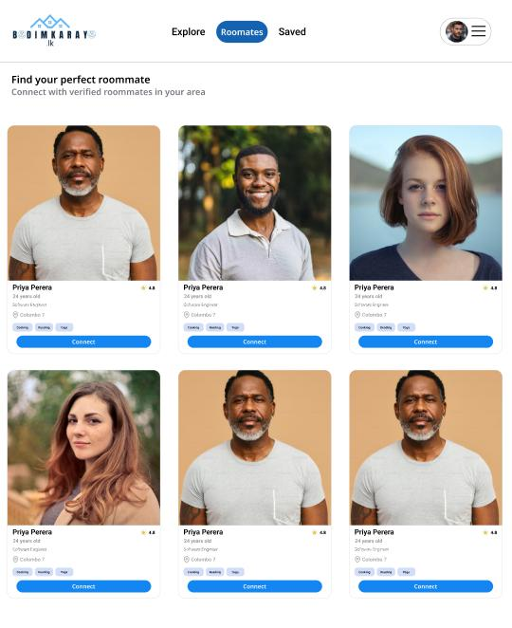
System Mock-up Screens

Reviews and Ratings

Description and Priority
The Reviews and Ratings feature allows users to provide feedback on properties by submitting ratings and textual reviews. This helps other users make informed decisions and improves trust within the platform.

Priority: Medium

- Benefit: 8
- Penalty: 7
- Cost: 5
- Risk: 4

Stimulus/Response Sequences
Stimulus | System Response
User submits a review | System validates and stores review
User views property | System displays associated reviews
User deletes review | System removes review
User submits invalid input | System returns validation error

Functional Requirements / User Stories
- REQ-F-300: The system shall allow authenticated users to submit reviews for properties.
- REQ-F-301: The system shall allow users to provide a rating (e.g., 1–5 scale).
- REQ-F-302: The system shall store review content along with user and property reference.
- REQ-F-303: The system shall display reviews for each property.
- REQ-F-304: The system shall allow users to delete their own reviews.
- REQ-F-305: The system shall prevent unauthorized users from modifying or deleting others reviews.
- REQ-F-306: The system shall validate review input (non-empty content, valid rating range).
- REQ-F-307: The system shall display appropriate error messages for invalid inputs.

User Stories

User story ID: US-30
User Role: Tenant / Registered User
Description: As a user, I want to submit a review so that I can share my experience with others.
Acceptance Criteria:
- User enters valid rating and review text
- Review is stored successfully
- Confirmation message displayed

Supporting Information/Reference: Review form UI
Output: Review saved and displayed
Dependencies: User must be authenticated, Property must exist
Integration: Frontend review form

User story ID: US31
User Role: Guest / Tenant
Description: As a user, I want to view reviews so that I can evaluate properties.
Acceptance Criteria:
- Reviews are displayed on property page
- Ratings are visible

Supporting Information/Reference: Property detail page
Output: List of reviews displayed
Dependencies: Reviews must exist in database
Integration: Backend API, Frontend UI

User story ID: US32
User Role: Registered User
Description: As a user, I want to delete my review so that I can remove incorrect or outdated feedback.
Acceptance Criteria:
- User deletes own review
- Review is removed from system

Supporting Information/Reference: Review management UI
Output: Connection request created
Dependencies: Ownership validation
Integration: Database operation

Use case diagram
Use Case ID: | UC-30
Use Case Name: | Submit Review
Created By: | Bodhinayake B.D.S.S. | Last Updated By:
Date Created: | 11/04/2026 | Date Last Updated:

Sequence Diagram
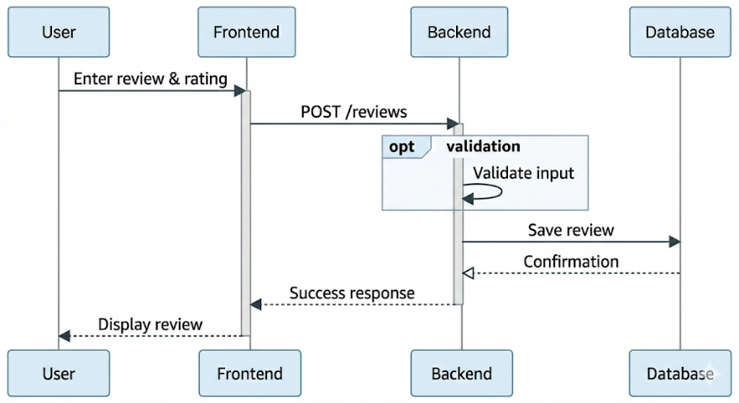
Draw the sequence diagram for the relevant system feature or use case

Sample

System Mock-up Screens
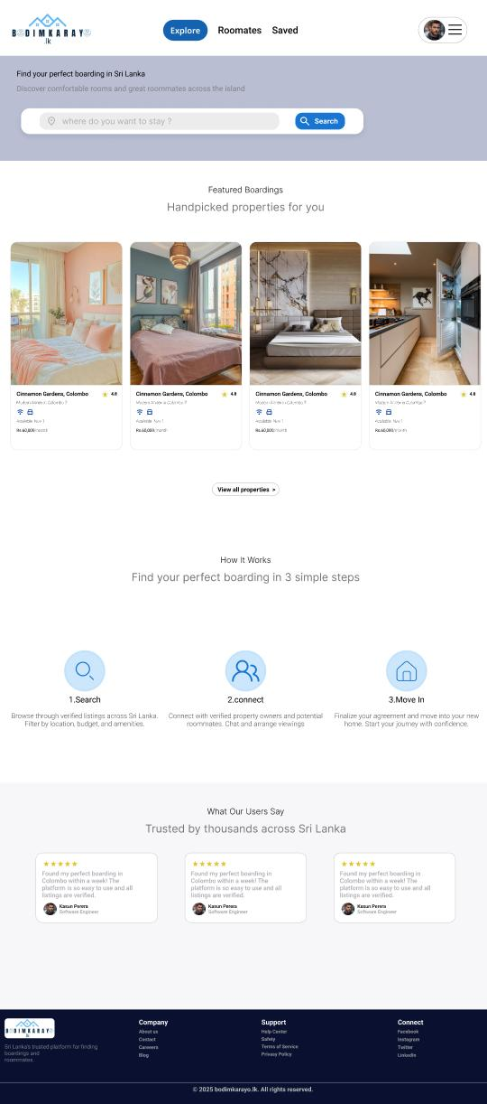

Logical Database Requirement

Introduction
The Logical Database Requirements define the structure and organization of data used in the Bodimkarayo.lk system. The system manages various types of data related to users, property listings, roommate posts, reviews, and administrative activities. These data elements support the core functionalities of the platform, including property searching, roommate matching, and user interaction.

Types of Information
The system stores and processes the following types of information:
- User Information: Name, email, password, role, and profile image
- Property Information: Title, description, rent, location, facilities, images, and availability details
- Roommate Post Information: User preferences, budget, lifestyle details, and accommodation requirements
- Review Information: Ratings and textual feedback provided by users
- Administrative Data: System logs including actions performed and timestamps

Frequency of Use
- User data is accessed frequently for authentication, authorization, and profile management
- Property data is accessed very frequently for browsing, searching, filtering, and viewing details
- Roommate posts are accessed frequently by users searching for shared accommodation
- Review data is accessed moderately when users view property or roommate details
- Administrative logs are accessed occasionally by system administrators for monitoring and auditing

Access Capabilities
The system provides different access levels based on user roles:
- Guests can view property listings and roommate posts
- Registered Users can create, update, and delete their own property listings and roommate posts
- Users can submit and view reviews
- Administrators have full access to all system data, including user management and administrative logs

Data Entities

User
Stores account credentials, role information, and user profile details.
Attributes:
- user_id (Primary Key)
- full_name
- email (Unique)
- password_hash
- role
- verified
- is_active
- profile_image_url
- created_at
- updated_at
- deleted_at

Property
Stores rental property listings published by owners.
Attributes:
- property_id (Primary Key)
- title
- description
- rent
- location
- address
- available_from
- property_type
- number_of_people
- bedrooms
- kitchens
- bathrooms
- floor
- furnished
- parking
- pets_allowed
- map_embed_url
- offers
- highlights
- rules
- nearby_places
- images
- owner_id (Foreign Key → User)

RoommatePost
Stores roommate-seeking posts and user preferences related to shared accommodation.
Attributes:
- post_id (Primary Key)
- user_id (Foreign Key → User)
- gender
- age
- occupation
- location
- bio
- about
- interests
- preferences
- preferred_location
- move_in_date
- budget

Review

Stores ratings and comments submitted by users for properties.
Attributes:
- review_id (Primary Key)
- user_id (Foreign Key → User)
- property_id (Foreign Key → Property)
- rating
- comment

AdminLog
Stores system activity logs for administrative monitoring.
Attributes:
- log_id (Primary Key)
- action
- timestamp
- admin_id (Foreign Key → User)

Data Relationships
The relationships between entities are defined as follows:
- A User can create multiple Properties. (One-to-Many)
- A User can create multiple RoommatePosts. (One-to-Many)
- A Property can have multiple Reviews. (One-to-Many)
- A User can write multiple Reviews. (One-to-Many)
- An Admin User can create multiple AdminLogs. (One-to-Many)

Integrity Constraints
To maintain data consistency and validity, the following constraints are applied:
- Each user must have a unique email address
- All primary keys must be unique and non-null
- Foreign keys must reference valid existing records
- Mandatory fields such as email, password, and property title cannot be null
- Reviews must be associated with valid users and properties
- A property must be linked to a valid owner (user)

Data Retention Requirements
- User data and profiles are retained as long as the account is active
- Property listings are stored until deleted by the owner or administrator
- Roommate posts are retained until removed or expired
- Review data is retained to maintain historical feedback and trust
- Administrative logs are stored for monitoring, auditing, and security purposes

Data Model Representation
The logical structure of the database, including entities and relationships described above, is illustrated using an Entity-Relationship (ER) diagram.
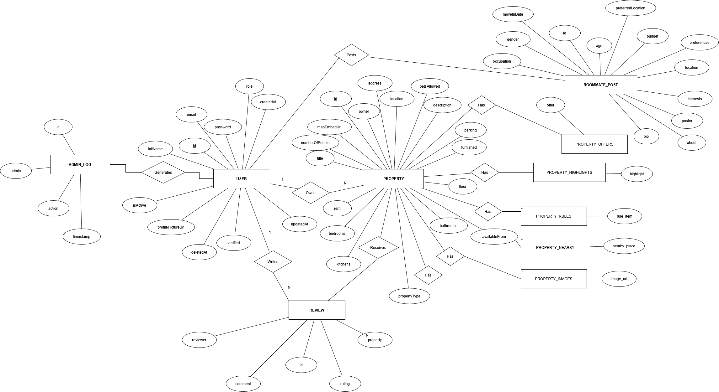

Non-functional Requirements

Introduction

The non-functional requirements define the quality attributes, constraints, and operational conditions of the Bodimkarayo.lk system. These requirements ensure that the system performs efficiently, remains secure, and provides a reliable and user-friendly experience. The system is designed to support both the web application and the mobile application using a shared backend infrastructure.

Performance Requirements
- REQ-NF-001: The system shall respond to API requests within 3 seconds under normal operating conditions.
- REQ-NF-002: The system shall support at least 100 concurrent users without significant performance degradation.
- REQ-NF-003: The system shall load web pages within 4 seconds on standard broadband connections.
- REQ-NF-004: Image upload operations shall complete within 5 seconds for standard image sizes.
- REQ-NF-005: The system shall efficiently handle search queries for properties and roommate posts with minimal delay.

Safety Requirements
The system does not involve direct physical safety risks. However, safeguards are implemented to prevent misuse and ensure safe operation:
- The system shall validate all user inputs to prevent incorrect or harmful data entry.
- The system shall provide error messages for invalid operations.
- The system shall allow administrators to monitor and handle suspicious activities.

Security Requirements
- REQ-NF-010: The system shall use JWT-based authentication for secure user access.
- REQ-NF-011: The system shall encrypt user passwords using secure hashing (e.g., BCrypt).
- REQ-NF-012: The system shall enforce role-based access control for users and administrators.
- REQ-NF-013: The system shall validate and sanitize all user inputs to prevent security vulnerabilities.
- REQ-NF-014: The system shall restrict administrative functions to authorized users only.
- REQ-NF-015: The system shall protect user data from unauthorized access and modification.
Future Enhancements:
- Email verification for user registration
- Rate limiting to prevent abuse and attacks

Software Quality Attributes
This section specifies the quality characteristics of the Bodimkarayo.lk system. These attributes define how well the system performs in terms of usability, reliability, security, and other important aspects. The priorities (High, Medium, Low) indicate the relative importance of each attribute for the successful operation of the system.

ID | Characteristic | H/M/L | 1 | 2 | 3 | 4 | 5 | 6 | 7 | 8 | 9 | 10 | 11 | 12
1 | Correctness | H
2 | Efficiency | H
3 | Flexibility | M
4 | Integrity/Security | H
5 | Interoperability | M
6 | Maintainability | H
7 | Portability | M
8 | Reliability | H
9 | Reusability | M
10 | Testability | M
11 | Usability | H
12 | Availability | H

Correctness

The system shall ensure that all functionalities operate according to the specified requirements. Data such as user details, property listings, and roommate posts shall be accurate and consistent.

Efficiency

The system shall provide fast response times for user actions such as searching properties, loading pages, and uploading images. Efficient use of system resources is maintained to support smooth operation.

Integrity/Security

The system shall protect user data using secure authentication mechanisms, password encryption, and role-based access control. Unauthorized access to sensitive data shall be prevented.

Reliability

The system shall operate consistently with minimal failures. Proper error handling and recovery mechanisms shall ensure continuous service without unexpected crashes.

Availability

The system shall be accessible at all times with minimal downtime. Users shall be able to access services such as property browsing and roommate searching whenever required.

Maintainability

The system shall follow a modular and well-structured design, allowing developers to easily update, fix, and enhance the system in the future.

Flexibility

The system shall allow future modifications, such as adding new features (e.g., mobile application support and recommendation improvements) with minimal changes to the existing structure.

Interoperability

The system shall be capable of interacting with external services such as media storage and mapping services through standard APIs.

Portability

The system shall be accessible across different devices and platforms, including web browsers and future mobile applications.

Reusability

System components shall be designed in a way that allows reuse in other parts of the system or future projects.

Testability

The system shall be structured to support testing through unit testing, integration testing, and end-to-end testing.

Usability
The system shall provide a user-friendly and intuitive interface that allows users to easily navigate and perform tasks such as searching for properties, posting listings, and finding roommates.
- The system shall provide a responsive design that works across different screen sizes, including desktops and mobile devices.
- The system shall ensure that users can complete key tasks (e.g., property search or posting) within a few simple steps.
- The system shall provide clear labels, instructions, and feedback messages for all user actions.
- The system shall display error messages in a clear and understandable manner.
- The system shall maintain a consistent layout and design across all pages.

Business Rules
- Only registered users can create property listings and roommate posts.
- Users can only modify or delete their own listings and posts.
- Reviews must be associated with valid users and properties.
- Administrators have full control over system data, including user management and monitoring.
- Unauthorized users shall not access restricted system features.

Other Requirements

Online User Documentation and Help System Requirements
The system shall provide user guidance through validation messages, prompts, and error notifications. Future versions may include a dedicated help section or FAQ for user assistance.

Purchased Components
The system utilizes third-party components including:
- Cloudinary for image storage and management
- MariaDB for data storage
- React for frontend development
- Spring Boot for backend API development

Interfaces
The system supports the following interfaces:
- RESTful APIs over HTTP/HTTPS
- JSON data format for communication
- Multipart file upload for handling images

User Interfaces
The system provides a responsive web-based user interface with:
- Login and registration forms
- Property listing and search pages
- Roommate posting and browsing pages
- Profile management screens
The design ensures usability across different screen sizes and devices.

Hardware Interfaces
The Bodimkarayo.lk system does not require direct interaction with specialized hardware components. However, it operates on standard user devices with the following characteristics:
- The system shall support access via desktop computers, laptops, tablets, and smartphones.
- The system shall be compatible with standard input/output devices such as keyboards, touchscreens, and displays.
- The system shall rely on internet connectivity (Wi-Fi or mobile data) for communication between client devices and the backend server.
- The system shall utilize device hardware such as cameras indirectly for image upload through browser or mobile interfaces.

Software Interfaces
The Bodimkarayo.lk system interacts with multiple software components, including frontend applications, backend services, databases, and external platforms. These interfaces enable data exchange, processing, and service integration across the system.

Frontend - Backend Interface (Web Application)
- The web frontend communicates with the backend through RESTful APIs.
- All requests and responses are formatted using JSON.
- Secure communication is maintained using HTTP/HTTPS protocols.
- Authentication is handled using JWT tokens included in request headers.
- The frontend sends user inputs such as login credentials, property data, roommate posts, and search queries.
- The backend returns responses such as user information, property listings, search results, and system messages.

Mobile Application Interface
- The mobile application communicates with the backend using RESTful APIs over HTTP/HTTPS.
- Data exchange between the mobile application and backend is performed using JSON format.
- Authentication is managed using JWT-based token mechanisms.
- The mobile application accesses the same backend services and database as the web application.
- All functionalities such as property browsing, roommate posting, and profile management are supported through the mobile interface.

Backend - Database Interface
- The backend communicates with the database using an Object-Relational Mapping (ORM) framework.
- The database stores structured data including users, properties, roommate posts, reviews, and administrative logs.
- Standard database operations such as create, read, update, and delete (CRUD) are supported.
- Data integrity is maintained through primary keys, foreign keys, and validation constraints.

External Service Interfaces
The system integrates with external services to extend functionality:
- Media storage services are used for uploading, storing, and retrieving images associated with properties and user profiles.
- Map or location services are used to display geographical information related to property listings.

Data Exchange and Communication
- Input data includes user registration details, login credentials, property listings, roommate preferences, and search parameters.
- Output data includes property details, roommate posts, recommendations, user profiles, and system notifications.
- All data exchanged between components shall follow a consistent JSON structure.

Constraints and Standards
- All interfaces shall follow REST API design principles.
- Communication between components shall be stateless.
- Data consistency shall be maintained across all system components.
- All interactions shall comply with security and validation requirements.

Communications Interfaces
The system uses standard communication protocols to enable interaction between users, servers, and external services.
- Communication between the client (web/mobile) and backend server shall use HTTP/HTTPS protocols.
- All data exchanged shall be formatted in JSON.
- Secure communication shall be ensured using HTTPS encryption.
- Authentication shall be handled using token-based mechanisms (JWT).
- The system shall support web-based access through modern web browsers.
- Data transmission shall be optimized to minimize latency and ensure fast response times.
- The system shall handle asynchronous communication for operations such as image uploads.

Licensing Requirements
The system uses open-source frameworks, libraries, and third-party services. All components must comply with their respective licensing terms.

- Frontend and backend frameworks shall be used under their open-source licenses.
- Database systems and development tools shall comply with their licensing agreements.
- External services such as media storage platforms may have usage limitations or subscription-based models.
- The system shall ensure that no component violates licensing or intellectual property rights.

Legal, Copyright and Other Notices
The system shall comply with applicable legal and ethical standards regarding user data and content.
- The system shall protect user privacy and handle personal data securely.
- Users shall be responsible for the content they upload (e.g., property details, images, reviews).
- The system shall include terms of service and privacy policies in future versions.
- Unauthorized use, duplication, or distribution of system content shall be restricted.
- The system shall ensure compliance with relevant data protection regulations where applicable.

Applicable Standards
The system adheres to recognized software development and operational standards.
- REST API design standards for communication between frontend and backend
- Secure coding practices to prevent vulnerabilities such as injection attacks and unauthorized access
- Software testing standards including unit testing, integration testing, and system testing
- Web usability standards to ensure accessibility and ease of use
- Data handling and validation standards to maintain consistency and accuracy
These standards ensure that the system is reliable, secure, maintainable, and scalable.

System Architecture
Bodimkarayo follows a layered system architecture to support clear separation of concerns, maintainability, and scalability. The architecture is organized so that user-facing functions such as search, listing management, roommate matching, and reviews are handled in the presentation layer, business logic is managed in the backend service layer, data persistence is centralized in a relational database, and media assets are managed through an external media service.
This architecture supports both web and mobile clients and allows future extensions such as advanced recommendation features without requiring major redesign.
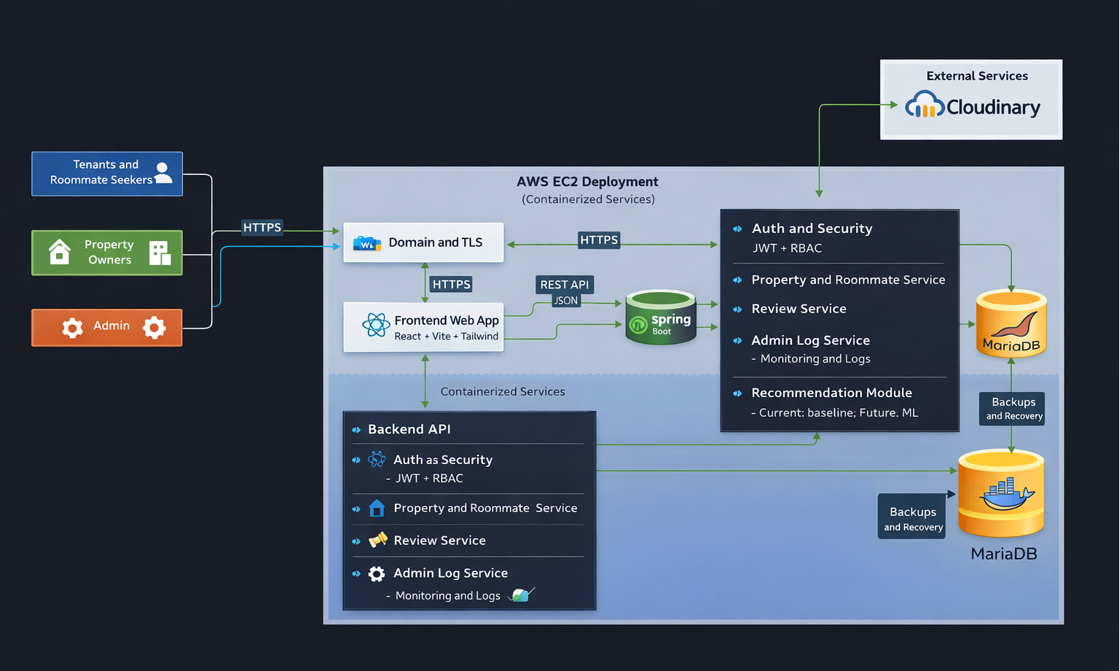

Functional Architecture
The functional architecture groups system operations into major functional domains.
- Identity and Access Management
Handles user registration, login, role management, session and token handling, and access control.
- User Profile Management
Supports profile viewing, updating, and profile image management.
- Property Lifecycle Management
Enables creation, updating, deletion, and viewing of property listings with detailed attributes and images.
- Property Discovery and Selection
Provides browsing, filtering, location-based search, and detailed property viewing.
- Roommate Matching Workflow
Supports creation and management of roommate posts, browsing profiles, and preference-based discovery.
- Review and Rating System
Allows users to submit and view reviews to support trust and decision-making.
- Administrative Monitoring
Provides logging and monitoring of system activities for operational control.
- Recommendation Functionality
Generates suggestions for properties and roommates based on user preferences.

Functional Hierarchy
- User Services
  - Identity and Access
  - Profile Management
- Marketplace Services
  - Property Management
  - Property Discovery
  - Roommate Management
  - Reviews
- Platform Services
  - Recommendation
  - Administrative Monitoring
  - Media Handling

Logical Architecture
The logical architecture organizes the system into abstract layers based on responsibilities.
- Presentation Layer
Handles user interaction through web and mobile interfaces.
- API Interface Layer
Exposes RESTful endpoints, validates requests, and routes operations.
- Service Layer
Contains business logic for authentication, property management, roommate matching, reviews, and administration.
- Persistence Layer
Manages data storage and retrieval using database entities and repositories.
- Integration Layer
Handles communication with external services such as media storage and future integrations.
- Cross-Cutting Concerns
Includes security, validation, exception handling, and configuration management.
This layered structure reduces coupling, improves maintainability, and allows independent development and testing of system components.

Component Architecture
The component architecture defines the major deployable units of the system and their interactions. Each component represents a logical part of the system that performs a specific function and communicates with other components through defined interfaces.
The main components of the system are:
- Frontend Web Component
Developed using React, this component provides the user interface and handles user interactions. It communicates with the backend through RESTful APIs.
- Mobile Application Component
Developed using Flutter, this component provides mobile access to system features and interacts with the backend using the same API endpoints.
- Backend API Component
Developed using Spring Boot, this component implements the core business logic, processes requests, and manages communication between other components.
- Security Component
Responsible for authentication and authorization using JWT tokens and role-based access control mechanisms.
- Database Component
Implemented using MariaDB, this component stores persistent data including user information, property listings, roommate posts, reviews, and logs.
- Media Service Component
Uses Cloudinary for storing and retrieving images such as property photos and user profile pictures.
- Recommendation Component
Provides recommendation functionality based on user preferences and system data.
- Logging Component
Captures system activities and administrative actions for monitoring and auditing purposes.

Component Interactions
- The frontend and mobile components interact with the backend via REST APIs over HTTP/HTTPS.
- The backend interacts with the database for data storage and retrieval operations.
- The backend communicates with the media service for image upload and access.
- The security component is integrated with the backend to enforce authentication and authorization.
- The recommendation and logging components depend on the core data managed by the backend.
This architecture ensures modularity, scalability, and maintainability by separating system responsibilities into independent components.

Physical Architecture
The physical architecture of the Bodimkarayo system shows how the software components are deployed on the underlying infrastructure. The system is implemented as a client-server application hosted in a cloud environment using AWS EC2, with Docker containers used to package and run the main services.
In the deployed environment, users access the system through desktop browsers, mobile browsers, and mobile application clients over the internet. Requests are sent using HTTPS to the public application host, where a reverse proxy or web server handles routing and secure communication. The frontend is deployed as a React-based web application, while the backend is deployed as a Spring Boot REST API service.
The backend communicates with a MariaDB database for persistent storage of application data, including user accounts, property listings, roommate posts, reviews, and administrative logs. Media files such as profile images and property images are stored externally using Cloudinary. Persistent database storage is maintained through database volumes or managed database services. Runtime configuration values such as database credentials, JWT secrets, and external service keys are provided through environment variables.

Deployment Structure
- Client Devices
  - Desktop browsers
  - Mobile browsers
  - Mobile application clients
- Cloud Infrastructure
  - AWS EC2 instance hosting the application
  - Docker containers for frontend and backend services
  - Reverse proxy or web server for HTTPS routing
- Data Storage
  - MariaDB database server
  - Persistent storage for database data
- External Services
  - Cloudinary for media storage and delivery

Physical Mapping of Components
- React frontend → frontend container or web hosting service
- Mobile application → client device
- Spring Boot backend → backend container on EC2
- MariaDB → database server or container
- Cloudinary → external cloud media service
- Security configuration and JWT handling → backend service layer
- Logs and system records → database storage

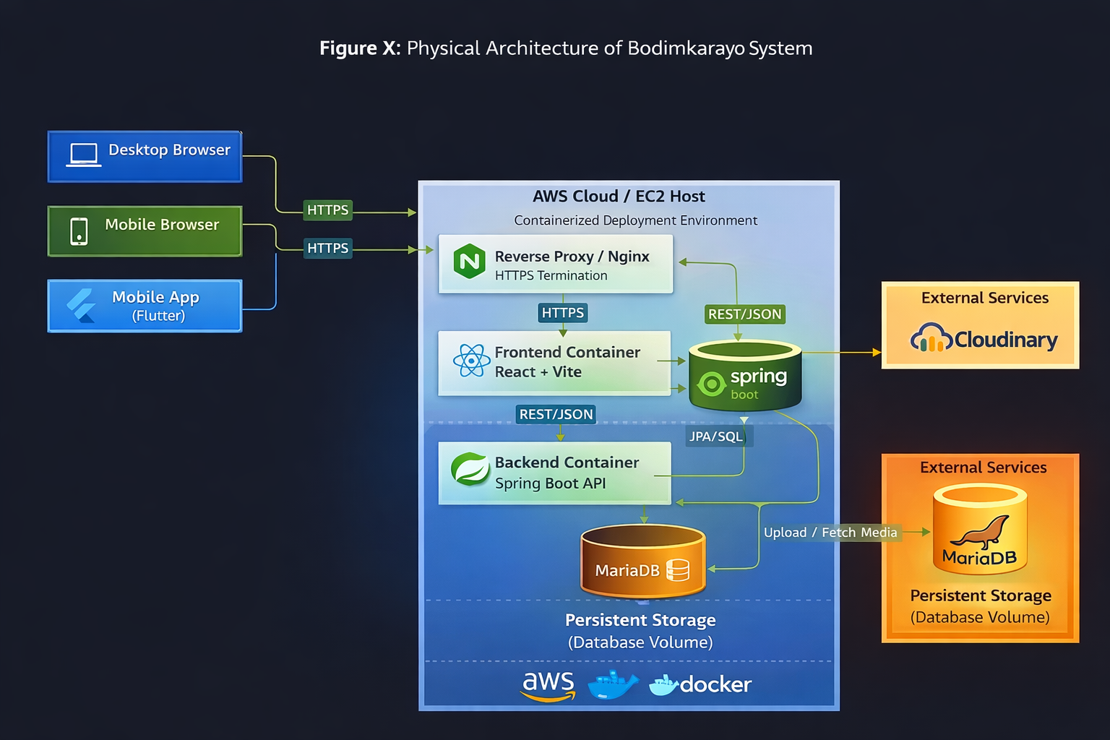

Appendix A: Glossary
Term / Acronym | Definition
Bodimkarayo | The platform developed for finding rental properties and roommates in Sri Lanka.
Bodima | Local term for boarding or shared accommodation.
SRS | Software Requirements Specification document.
User | Any person using the system, including tenants, owners, and administrators.
Tenant / Seeker | User searching for properties or roommates.
Owner / Landlord | User who publishes and manages property listings.
Admin | Privileged user responsible for system monitoring and moderation.
Listing | A property advertisement containing details such as rent, location, and images.
Roommate Post | A user-created post to find a compatible roommate.
Profile | User account information including personal and contact details.
Review | Feedback and rating submitted by users.
Recommendation | Suggested properties or roommates based on user preferences.
API | Application Programming Interface used for communication between system components.
REST | Representational State Transfer, the API design style used in the system.
JSON | JavaScript Object Notation, the data format used for API communication.
JWT | JSON Web Token used for authentication and authorization.
RBAC | Role-Based Access Control based on user roles (USER, OWNER, ADMIN).
CRUD | Create, Read, Update, Delete operations on system data.
Frontend | Client-side application developed using React.
Backend | Server-side application developed using Spring Boot.
Spring Boot | Java framework used to build backend REST services.
React | JavaScript library used for building the user interface.
MariaDB | Relational database used for storing application data.
JPA | Java Persistence API used for database interaction.
Repository | Data access layer used for database operations.
Service Layer | Business logic layer between controllers and data access.
Controller | Backend component that handles API requests.
DTO | Data Transfer Object used for API request and response structures.
Cloudinary | Cloud-based service used for image storage and delivery.
EC2 | Amazon Elastic Compute Cloud used for hosting the application.
AWS | Amazon Web Services cloud platform.
Docker | Platform used for containerizing application services.
Docker Compose | Tool for managing multi-container applications.
Nginx | Reverse proxy server used for routing and HTTPS handling.
TLS | Transport Layer Security protocol for secure communication.
HTTPS | Secure communication protocol using TLS encryption.
CORS | Cross-Origin Resource Sharing policy for controlling API access.
CI/CD | Continuous Integration and Continuous Deployment workflow.
TBD | To Be Determined item not finalized during SRS preparation.

Appendix B: Analysis Models
Class Diagram
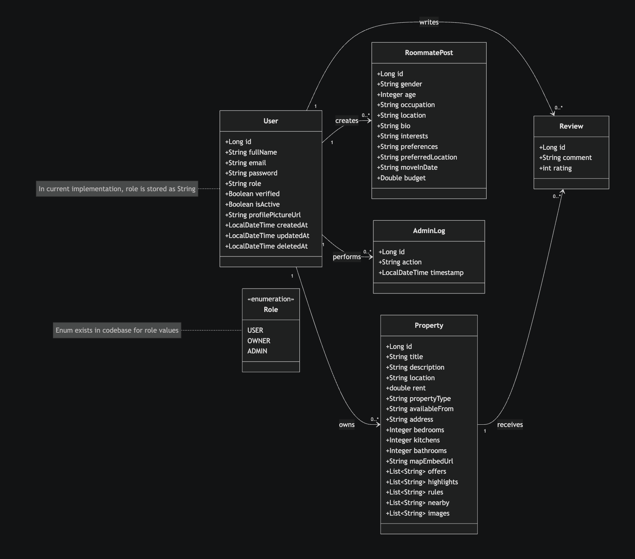

Appendix C: To Be Determined List
- TBD-01: Recommendation Engine Design
- TBD-02: Messaging System Design
- TBD-03: Admin Dashboard Features
- TBD-04: User Verification Workflow
- TBD-05: Notification System Design

